Names&IDs

Nada Moursi, ID#900191127

John El Gallab, ID# 900193761

Youssef Agiza, ID# 900192237

---------------------------------------------------------------------------------------------------------------------------

Project Description:

Classical Pacman game, as nostalgic as possible :)

---------------------------------------------------------------------------------------------------------------------------

Classes description:

1. Board: Class to create pacman board
2. Pellets: Class that creates pellets, power pellets, and fruits randomly.
3. Character: virtual/parent class from which Pacman and ghosts will inherit
4. Pacman: Class to create Pacman and handle its properties such as movements, power up and animation
5. Ghost: Class to create ghosts, handle its AI and other properties such as freight mode.
6. GhostManager: Class to create a list of 4 ghosts and initialize each one with different properties that corresponds to each ghost in the original game.
7. IObserver/ISubject: Design pattern called Observer. It is used to notify the ghosts when pacman eats power pellets
8. MinHeap: utility class used in dijkstra to get path for ghosts AI
9. Graph: utility class that returns path for the ghosts to follow
10. Words: Controls the display of text on the renderwindow during the game at any point
11. Email: controls sending an email to this game moderator (us) whenever one game is played till the end(player either wins or loses). Expandable to update the players themselves on their emails with their new scores etc…
12. Audio: Class that controls playing an audio when pacman eats a pellet, pacman die, and ghost eaten in freight mode etc….
13. Game manager: class that basically controls the game. Orchestrates the performance and runs the code in a logical order. Handles the end result of the game. Called in the main function to run the game and do everything.

//Those classes have not been linked to the final project but are fully functional on their own :)

1. game : Class that creates a window which is basically a video mode then adds new state after a specific amount of time passes.
2. MainMenu: Class that loads the textures, sets them and displays them on the screen.
3. Splash: Class the load a texture(logo) and draw it on the screen and then update the clock so when the given time passes, it goes into the main menu.
4. PlayerList: Keeps track of the player and their playtime/ number of wins/losses etc….
5. Input manager: is a class that knows if the user clicked or the screen or not and acts upon it.
6. MenusM: is a class that the main menu class and splash class inherits from to load,set,and get the texture.
7. stateMachine: is basically a class that updates the state of the game and changes it when the process state change is called.

---------------------------------------------------------------------------------------------------------------------------

UML Design:

<https://app.diagrams.net/#G1KvpXAk873oY1Vddj8DRnHJaMjAnyAJ64>

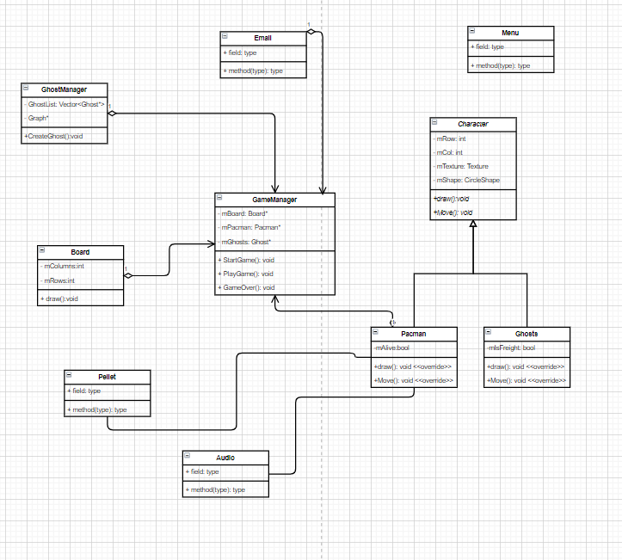

---------------------------------------------------------------------------------------------------------------------------

List of Bonuses:

1. Audible effects when game is played
2. Fruits drawn randomly to increase score and may allow for extra freight mode
3. Email sending
4. Implementation of singleton design pattern in audio
5. Implementation of Observer design pattern in Pacman and Ghosts class
6. Animation for both pacman and ghosts (change colors, move eyes, animate death, etc…)
7. Extra AI for Clyde: moves randomly to have different movement patterns from the other ghosts. Note: Clyde moves randomly in the original game as well.
8. Extra AI for Pinky: uses AI to try and get ahead of pacman’s location
9. Uses vectors of vectors, adjacency lists, pointers to function
10. Main menu attempt (not linked to the actual but coded in 5 classes)
11. Attempt at loading files in a linked list of structures and keep track of the highest score ever (not linked to the actual game)

---------------------------------------------------------------------------------------------------------------------------

Please understand that our individual reports will be submitted in the upcoming hours just after the 7 AM deadline, but definetly before the 11:59 PM deadline.

Thank you for your understanding :)